To:

From:

Date: [date due]

Subject: [insert memo subject here]

Purpose of this project was to develop any kind of robot which can perform for the RoboGames, and there were different competitions that can take part with the robot. From these competitions we have decided to develop a robot which can take part in the balancing competition. Balancing competition will check the robot balancing on different terrains and the robot need to travel for 3 minutes or less than that and the robot need to move in the arena of 180 meters for showing the balancing. With all these descriptions we have started the design project and selected the design first after generating multiple ideas. The description provided by the client and the Robogames have used to make the customer requirements table which tabularize the important points for the project requirements and then from these customer requirements and description, we have generated the engineering requirements. These engineering requirements have generated so the project can identify what need to build physically and it can measure through different equipment. By measuring these technical values, it can justify at the end that the final product has developed according to the requirements of client or not. Then house of quality chart has developed to make the relationship between customer requirements and engineering requirements and then identify which engineering requirement is at the top priority and which is at least priority. In the QFD chart, targeted values and tolerances for each engineering requirement has defined as well so it can justify which things can change and to what extent. After the QFD we have done the concept generation and sketches the ideas for the final design. In order to generate these ideas a complete research has done before and see what has done till now and what types of robots have developed so we can understand the robotics in better way and develop the robot up to the mark. After the research and literature review we have generated the concepts using different methods including brain storming. From these sketches the final design has selected using the Pugh chart and decision matrix. Pugh chart has narrowed down the generated concepts to top three and then decision matrix has used to select the final design. The final design has selected, that is a two wheeler robot with the double stand on it and sonars in front side and gyroscopes on both sides to balance properly and sonars to detect the hurdles. The double stand has used to put all the components easily on it.

As the final design has selected and it was only a sketch formed by hand, so after that a CAD model has developed for each component. The CAD model developed for the final design was 3D model and each component has developed with the proper dimensions and then assembled all the parts to make the final design. Reason for making the CAD model is to see the design clearly and identify each part with its size. Also this CAD model explains the proper working of project and any person without the information can identify what the project is.

After the CAD model has developed it has then used to make a simple prototype. The reason for making the prototype is to see if the design can actually implement or not. The implementation process has done after the prototype. And another reason for the prototype was to see if anything need to change in the design or not. Further details about the implementation and design changes will provide in the next section. In the next section, implementation process will discuss in details which compromises of the complete setup including Arduino, sonar, wheels, motors, motor driver, batteries and the structure of the robot.

# Implementation

The implementation is a process of manufacturing the final design product for the project and the final product will be a two wheeler robot and in this implementation section we will talk about the process through which we are developing the product, like arranging the components, assembling them, and testing the components. This project contains several components which will assemble together to form the final product. The final product will test multiple times and remove all the bugs before it submitted. The implementation of final product starts from the manufacturing.

## Manufacturing

In order to do the manufacturing of products, we have decided to order all the parts online and for this purpose we have developed a list of product that need to buy first. The following list has developed

Table 1: List of items

|  |
| --- |
| Items |
| Servo Motor |
| Arduino |
| Controller |
| Blue Smurf Bluetooth |
| Strap Hinges |
| High gloss Tape |
| Screws |
| Battery |
| Battery Cells |
| Jumper Wires |
| Power Adopter |
| Glass |
| Wheels |
| Motor sensor |

After the list has generated, we have searched the products online for order, we have found multiple sites but we want to order them together so that all the components will arrive together and we will keep working on them without any delay, therefore, we have selected the Amazon on which all the items were available and we have placed the order for all the components, all the components were need to buy, there was nothing we have already. Arduino. jumper wires, motors and motor sensors were the components we need at first because these things need to interlink with each other and need to test as well. Therefore, these four components have ordered instantly and these components have used in the prototype as well. Some other components have used in the prototype as well like wheels, motor sensor, glass, gloss tape and battery. We have ordered them from the Amazon and when the products have arrived we have checked each component separately.

For the prototype testing, Arduino has interlinked with the motor using the jumper wires and motor sensor, and then motor sensor connects with the motor. The motor will further connect with the wheels which have not done in the prototype. The reason for discussing the prototype here is that these components have tested through the prototype. From the testing of each component we have seen that the engineering requirements have met. As the some of the engineering requirements have changed which have described in the previous section, so the new engineering requirements have stated below

Table 2: Engineering Requirements

|  |  |
| --- | --- |
| Engineering Requirements | Operational Values |
| Dimension | Less than 120 cm^2 |
| Battery Time | 15 minutes |
| Moving Capacity in the Arena | 50 meters |
| Height | 20 cm |
| Wheel Radius | 4 cm |
| Degree of Freedom | 2 Degrees |
| Width | 6 cm |
| Weight | 6 lb. |

The battery time has tested for the robot, we are using four batteries with the rating capacity of 20 mAh, so the total capacity of batteries is

$$Battery Capacity=10 mAh$$

$$Total Batteries capacity=10 mAh*4$$

$$Total batteries capacity=40 mAh$$

Now calculate the running time of total batteries. As the consumption current of the complete robot is 100 mA.

$$Current consume by Robot=100 mA$$

So the battery time is

$$Battery Time=\frac{Battery capacity}{Current consume}$$

$$Battery Time=\frac{40}{100}*60$$

$$Battery Time=0.4* 60$$

$$Battery Time=24 minutes$$

Hence the engineering requirement is that battery must run for at least 15 minutes, therefore from the experiment it is clear that battery can easily run for 15 minutes and it can up to 24 minutes, but that’s an ideal condition so it is clear that even in real conditions the battery will provide 15 minutes of power back up easily to the robot with all the components in working hence it is clear that engineering requirement has met here.

The next thing is the moving capacity of robot, as the requirement state that the robot need to move for 50 meters minimum. In order to see if the engineering requirement have met or not, we can calculate it as

$$Speed of Robot=1\frac{m}{s}$$

$$Time of robot=15 min$$

Convert the time from minutes to second

$$Time of robot=15*60$$

$$Time of robot=900 sec$$

So the robot can move for

$$Distance=speed*time$$

$$Distance=1*900$$

$$Distance=900 meters$$

Hence the robot can easily reach to 900 meters in 15 minutes and the requirement says it need to travel for 50 meters. So this engineering requirement has met as well. The remaining engineering requirements are the dimensions of the robot which have met already and the robot will develop according to these dimensions hence the major engineering requirements have measured and fulfilled.

## Design Changes

The implementation of the project has started yet but it has not completed and the implementation has started by assembling the components. The components have assembled without any structure just to testify whether the components are working or not. Following are the motors we have ordered

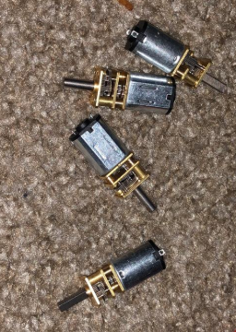

Figure 1: Motors

And the sensors we have ordered have shown below

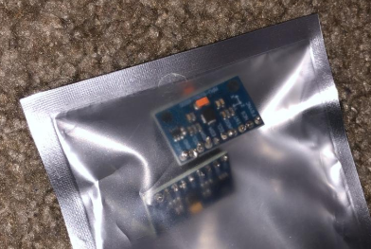

Figure 2: Sensors

And the batteries are

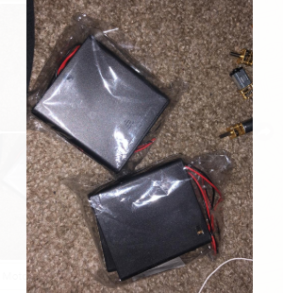

Figure 3: Batteries

To do so, we have coded the Arduino with a simple code to run the motor and burn the code on the Arduino microcontroller. After that we have connected the motor with the motor sensor through the wires and then connected the motor sensor with the Arduino.

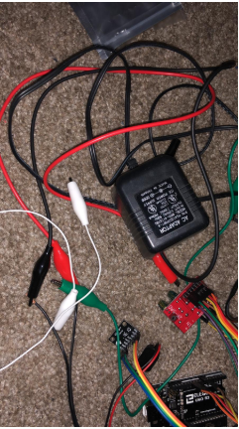

Figure 4: Connecting the jumper wires with the sensors though the Arduino

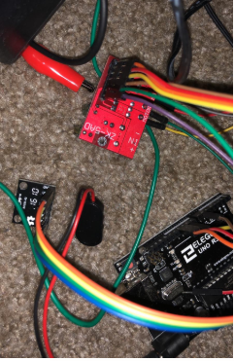

Figure 5: sensors connected with Arduino

The Arduino has connected with the motor, and then the battery has connected with the Arduino and the motor sensor to provide the power. The connection of Arduino with the sensors was quite difficult for us and it failed many times because ground and power pins were confusing and in some attempts pins were not connected tightly. After multiple attempts we have able to connected the sensors with the Arduino and the LEDs on the sensors were blinking to show the connections were good to go. Following figure is showing the Arduino with the connections.

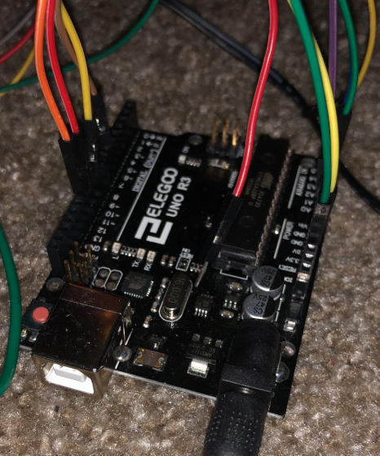

Figure 6: Arduino connections

After that the motor has run through the Arduino, the next thing is to implement the robotic structure. Building the robotic body is our next task that will perform in the future and then place all the components on it and final product will ready.

It is to notify here that we have not made lot of changes in the design but few manipulations done in the design have described in the next section.

### Design Iteration 1: Change in Battery discussion

The original system before was using one battery which provide enough battery backup to the robot but now we have decided to use 4 batteries as it can provide better battery backup and it can easy to handle four batteries and locate them at different positions to stabilize the robot. The batteries are showing below:

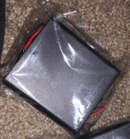

Figure 7: Battery shape

These battery banks are slim and can easily fit on the robot whereas if we use a single battery bank it will be bigger in size and will be difficult to manage on the robot and it will not let the robot balance properly. These four batteries can easily hold through the battery catcher and will easily fit into the slim robot. Also using the bigger battery was increasing the size of robot and the dimensions of the robot will not meet the engineering requirements that’s another reason for changing the number of batteries.

### Design Iteration 2: Number of Motors discussion

In the previous semester we have decided to use two motors that will run the wheels and move the robot, the motors were of bigger in size as well and it has used in the prototype as shown below.

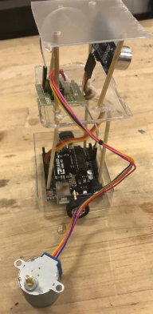

Figure 8: Motor

The round shape motor is showing clearly outside the robot prototype and this size of motor is quite big therefore we have decided to change the motor and the new motors we are using in the robot have shown below in the figure

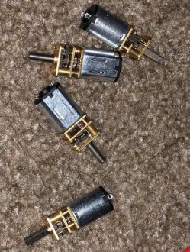

Figure 9: New Motors

The above motors are quite small in size, and before we were using only two motors now are using 4 motors replaced with the two big size motors. Hence in this way the motors sized have reduced as well as we will get a better torque and power strength to move the robot. Changing of size in motor also made easy for us to develop the robot of small size but it also looks better to use for the wheels.

### Design Iteration 3: Change the material of body discussion

We have decided earlier in the previous semester that body of the robot will be made up of steel because steel is strong and hard and if the robot will fall the steel body will not get any crack neither it will tear the robot into different parts but now we have decided to use the plastic for making the robot body. Reason for this change is that steel is not light weight and it will make the device heavier while the plastic is light in weight and it will keep the device within the defined weight so to meet the engineering requirement we have changed the decision but this has not implement yet neither we have ordered anything about the material that is the there is no picture or any other thing to give the proof of this change. But it can clearly understand through the densities of both materials

Table 4: Density of materials

|  |  |
| --- | --- |
| Material | Density ($g/cm^{3}$) |
| Plastic | 0.92 |
| Steel | 8.05 |

From these densities we calculate the weight of each material for 60 cm.

$$Volume=60 cm^{3}$$

$$mass=density*volume$$

$$mass of plastic=0.92*60$$

$$mass of plastic=55.2 g$$

And mass of plastic in lb.

$$mass of plastic=55.2* 0.002204$$

$$mass of plastic=0.122 lb.$$

Now mass of steel is

$$Volume=60 cm^{3}$$

$$mass=density*volume$$

$$mass of steel=8.05*60$$

$$mass of steel=483 g$$

And mass of steel in lb.

$$mass of plastic=483* 0.002204$$

$$mass of plastic=1.06483 lb.$$

Hence comparing the steel and plastic, plastic is light weight and it will make the robot strong enough and will keep the weight within the engineering requirement value of 5 lb.

# Future Implementation

We have ordered all the components almost and all the components have connected with each other for testing purpose. All the connections have made perfectly and after some difficulties the sensors and the Arduino are working using the motor and batteries. Now the next thing that we will do is to implement the robotic structure. This is our future plan to implement the body of robot and then arrange all the components on the robot body to get the final product. In the next section we will describe the schedule for the future implementation and the budget that has used and the remaining budget.

[Outline here where the team intends to go with the remainder of the manufacturing and design of the system. How is the team’s schedule set-up to accommodate the future deliverables of capstone? Provide a Gantt chart or equivalent schedule breakdown of who is in charge of what aspects of the project. Also provide a breakdown of the budget as it stands with what is purchased, what remains to be purchased, and what aspects of the system have not been designed or sourced yet (and why).]

## Further Manufacturing and Design

Further manufacturing for our project is only to develop the body of robot and we will develop the body using the plastic material and that’s the only remaining thing in our project. All the components have implemented and inline, just need to develop the body structure and arrange the components over it. The design is same, there is no change made in the design, the thing which has changed is only the material to use for the body. We have decided before to use steel sheet for making the robot body but now we have decided to use the plastic material for making the body as the plastic is light in weight and it can keep the robot strong and flexible.

For this purpose, we will order the plastic sheets online through the store, the plastic has not decided yet. We will cut the plastic using the cutter according to the size of arms and then will cut the upper and lower plates. To attach the plastic components, we will use the adhesive magic and will use the screws to tight it. For making the hole in the plastic we will use the driller that will drill the holes. Then assemble all the parts to make the final body of the robot.

## Schedule Breakdown

We will develop the body of robot using the plastic and then will arrange all the components over it and the final product will ready so the breakdown schedule has shown below for the manufacturing process and completing the final product.

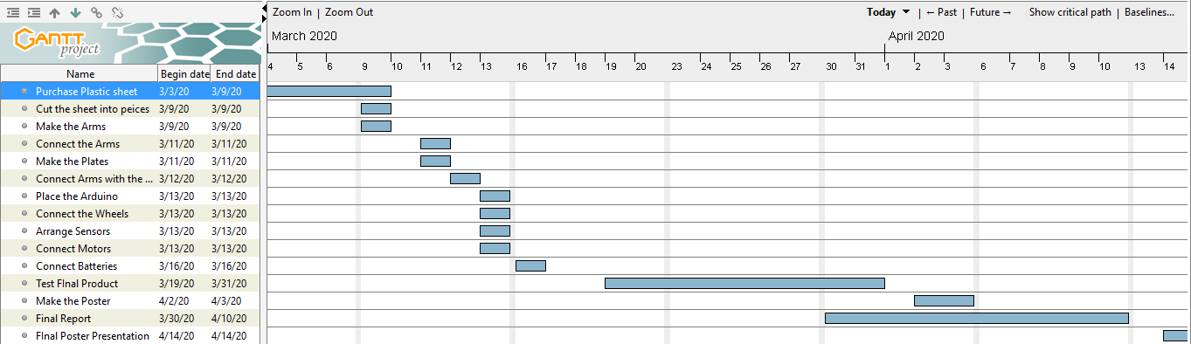

Figure 10: Gantt Chart

This is the schedule breakdown of the remaining work for the manufacturing and this whole work will do in the group so all the members of team will take part in it together.

## Budget breakdown

The budget has breakdown into the following items presenting in the following table

Table 5: Bill of Materials

|  |  |  |  |
| --- | --- | --- | --- |
| Items | Unit Price | Quantity | Total Cost |
| Motors | $13.99 | 4 | $55.96 |
| Battery Covers | $5.99 | 4 | $23.96 |
| Batteries | $14.50 | 4 | $58.00 |
| Gyroscope | $5 | 2 | $10.00 |
| Arduino Kit | $30 | 1 | $30.00 |
|  | Total Cost | | $177.92 |

Above items have ordered and used in the manufacturing process, remaining we will order the plastic sheet that will use to make the body of robot.